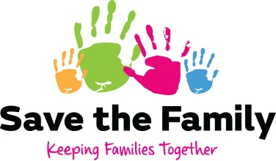

Equality and Diversity Monitoring Form

Save the Family is committed to equal opportunities and diversity. It is determined that in its provision of services and as an employer it will ensure equality of opportunity for all, regardless of age, race, gender (including gender reassignment), disability, marital status, sexual orientation, or religion or personal belief.

To help us implement and monitor this policy please could you provide us with the following information:

1. Gender

Male Female

2. Disability

Do you consider yourself to have a disability as defined under the Equality Act 2010?

Yes No

If yes, please give brief details:

3. Date of Birth ----/----/----- (Optional)

4. Ethnic Origin

Please circle the appropriate letter, A to E, then tick one box within that section to indicate your cultural background

A White

British
Irish
Any other white background, please state
ABOUT YOU

B Mixed

White and Black Caribbean
White and Black African
White and Asian
Any other mixed background, please state

C Asian, Asian British

Indian
Pakistani
Bangladeshi
Any other Asian background please state

D Black, Black British

Caribbean
African
Any other Black background, please state

E Chinese, Chinese British, Chinese English, Chinese Scottish, Chinese Welsh or other ethnic group

Chinese
Any other background, please state

5. Sexual Orientation

Bisexual
Heterosexual
Homosexual (Lesbian/Gay)
Other

6. Religion or Personal Belief (Please state):
7. Marital Status
Single
Married
Separated
Divorced
Widowed

Thank you. This information will be kept separate from your application form and will be treated in the strictest confidence.

