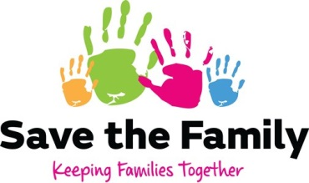
Can we contact you?
Name

Organisation (if applicable)

Email

Address

Thank you for taking the time to complete this form
Please TICK below if you would like to receive communications from Save the Family
- I would like to receive communications via email
- I would like to receive communications via Post
- I would like to receive a copy of your Privacy Policy
Due to the General Data Protection Regulation (GDPR), effective 25th May 2018, we have reviewed our privacy policy. If you would like to receive communications from Save the Family, please complete this form and email it to info@savethefamily.uk.com or send to Save the Family Ltd, P.O. Box 3825, Chester CH1 9BA.
Without your consent, we will not be able to communicate with you.

Would you like to receive communications from us about our news, events and updates?

